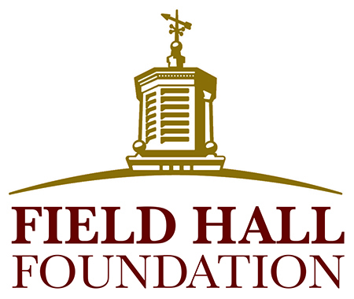

SAMPLE GRANT AGREEMENT

The Field Hall Foundation is awarding this grant subject to the following terms and conditions:

- Upon receipt of the signed agreement, the Foundation will contact the Grantee to schedule the transfer of the grant for the submitted project/program.

- Upon receipt of the grant, the Grantee will provide the Foundation with a donor acknowledgement letter, addressed to Field Hall Foundation, 118 N. Bedford Rd., Suite 100, Mt. Kisco, NY 10549. The letter should be addressed to the Foundation, not an individual, and state that no goods or services were provided in exchange for the grant. New grantees should also provide a copy of their logo as a jpeg document.

- The Grantee agrees to use the grant award solely for the project described in its proposal unless the Field Hall Foundation has given prior written approval for any modifications to the program or budget. The Grantee will treat the grant amount as a restricted asset and will keep accurate records to document the expenditure of funds and the activities supported by the grant. Any unexpended grant funds remaining at the end of the grant period will be returned to the Foundation unless a special agreement has been made for the spending of those funds.

- The Grantee agrees to use the funding within one year of the award and will submit an interim progress report (not applicable for small grants) and a year-end report to the Field Hall Foundation. These reports will summarize the project’s progress and expenses, and, for year-end, evaluate the project’s overall success. The reports are available on the Foundation’s website (www.Fieldhallfoundation.org) and will be provided to the Grantee closer to the due dates.

- The Field Hall Foundation reserves the right to review or audit applicable charges to the project. The Grantee may be required to refund part or all of the grant award if the grant is improperly expended, not completely expended, or if mutually agreed upon project objectives and timelines are not fulfilled.

- The Grantee agrees to allow the Foundation to conduct a site visit during and/or upon the completion of the project.

- The Grantee shall notify the Foundation of any changes in tax-exempt (or government unit) status, address, or overall financial health that may affect the operation of the project or the organization.

- The Grantee agrees to appropriately credit the Field Hall Foundation in any advertisement, publicity or public comment related to the grant’s project, and will obtain the Foundation’s approval prior to such activity. Products developed or purchased (such as a vehicle) using grant funds must be imprinted with the Foundation’s name and logo (the Foundation will provide a graphic of the logo), and a credit line stating, “Funded by a grant from the Field Hall Foundation.”

- The Grantee gives permission to the Foundation to publicize the grant and its details, including the grantee’s logo and pictures in relation to the grant.

- Future Funding: This agreement does not oblige the Foundation to provide the Grantee with additional or continued support. Previous grant recipients are eligible to submit another Letter of Inquiry after a) at least one year has passed since receiving a grant, and b) a final report for that grant has been submitted to and accepted by the Foundation. It is important to note that, because of the large number of organizations the Foundation supports, it generally takes approximately two years before previous grantees are considered for a new grant.

Any modification or amendment to this agreement will be made in writing and signed by authorized officers of the Grantee and Field Hall Foundation. Please confirm the agreement as stated above by signing the grant agreement and returning it by mail or email to:

Patti Lavan Horvath, Program Officer
Field Hall Foundation
118 N. Bedford Rd., Suite 100
Mt. Kisco, NY 10549
phorvath@fieldhallfdn.org

Upon receipt, the Foundation will contact you to schedule the presentation of the grant.

