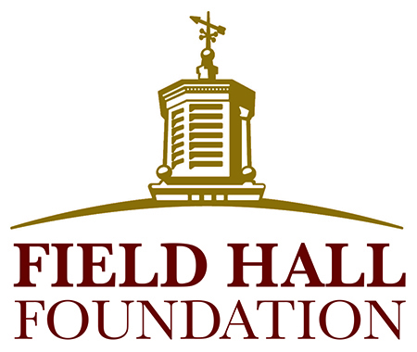

Interim Grant Report

As advised in your Grantee Agreement, an interim report on your project is to be submitted to the Field Hall Foundation by January 30th. The following information is requested to help us document the progress of your grant.

Please use 12-point Times New Roman font and limit the completed report to two pages or less (not including attachments).

- Date:
Organization Name:
Project/Program Name:
Name and Title of Person Filling Out Report:
Email and Phone Number:

- Describe the progress your organization has made toward accomplishing the goals and objectives of your project or program. Has it been necessary to make any changes to the program/project? If so, what and why? Are you on target to reach your goals by the end of the project/program? If not, why?

- Have there been any changes to the budget (attached) or will there need to be, to complete the project/program?

- Please attach copies of or provide links to the following, if available:
  - Any media coverage or communication products developed (i.e. brochures) regarding the project
  - Feedback or quotes from the seniors or caregivers involved with the project
  - Pictures (jpeg or tiff) of the project, including seniors and/or caregivers if possible. Please include a statement granting permission to the Foundation to use the pictures on the Foundation’s website, social media, reports, and brochures.

