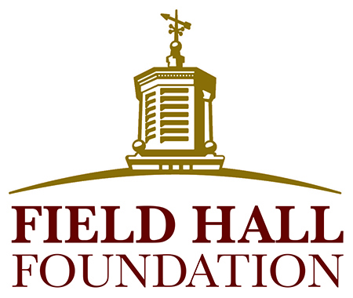

Final GRANT Report

As noted in your Grantee Agreement, a final report on your project is to be submitted to the Field Hall Foundation by December 31, 2025. The following information is requested to help us document the activities and outcomes of your grant.

Please use 12-point Times New Roman font, label each answer according to the question’s number, and limit the completed report to three pages or less (not including attachments).

- Date:
Organization Name:
Project/Program Name:
Name and Title of Person Filling Out Report:
Email and Phone Number:

- Overall, do you consider the project/program a success? Describe the outcome of each of the goals stated in the application submitted for this grant, with a short explanation as to why each was or was not met.

- Were there any unanticipated developments or lessons learned, either positive or negative? Was it necessary to make any changes or will changes be made going forward? Were there any additional outcomes not directly associated with the project’s objectives (i.e., partnerships formed, additional funding support gained)?

- How many unduplicated seniors and/or caregivers were impacted by the grant?

- Briefly summarize how you evaluated the success of the program. What do you consider the project’s most notable accomplishment(s)?

- Will the program continue? If so, how will it be funded?

(Continued)
- Based on the budget submitted with your proposal please attach a line-item summary of the actual use of the grant funds. Include explanations for any line items that saw more than a 10% change.

- Do you have any additional comments, including feedback and quotes from the seniors, caregivers, staff or volunteers directly involved?

- If possible, attach pictures (jpeg or tiff) of the program, including seniors and/or caregivers, and a statement granting the Foundation permission to use the pictures on the Foundation’s website, social media, reports, brochures, and fliers.

- Please attach copies of, or provide links to, any media coverage or communication products developed (i.e., brochures) for the program.

