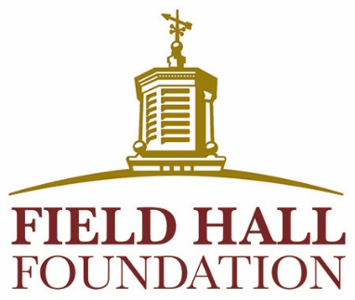

CONTACT INFORMATION

Patti Lavan Horvath
phorvath@fieldhallfdn.org
914-813-9103

Field Hall Foundation Awards $292,500 in Grants

CORTLANDT MANOR, NY, February XX, 2026 – Field Hall Foundation has announced $292,500 in grant awards to 14 nonprofit organizations through its Winter 2026 grant cycle. The funding will support programs that enhance older adults’ safety, health, and overall well-being; address food insecurity; and ensure access to essential services, including home repairs, vision rehabilitation, case management, and emergency financial assistance.

Winter 2026 grant recipients include:

VISIONS—$40,000
To provide personalized, in-home and residential vision rehabilitation services to improve seniors’ safety, independence, and quality of life

Westchester Community Health Center—$30,000
To improve the health and well-being of low-income seniors with chronic illnesses

WestCOP, Inc. —$30,000
To support low-income seniors with essential nutrition, hygiene resources, and emergency financial assistance

Cabrini of Westchester—$25,000
To upgrade the facility’s wander management system to ensure the safety of residents

Community Center of Northern Westchester—$20,000
To provide increased fresh produce, regular health screenings, education and nutrition counseling for seniors

Dutchess Outreach—$20,000
To provide nutritious food through their pantry and Lunch Box programs, and to support renovations at their program locations

Meals on Main Street—$20,000
To deliver high-quality food and meals to seniors

Putnam County Housing Corporation—$20,000
To provide home repairs for low-income senior homeowners

Second Chance Foods—$20,000
To increase access to fresh groceries and meals for seniors

Bethel Nursing Home Company, Inc.—$15,000
To provide a safe environment at their Adult Day Care Program

Cancer Support Community Greater NY and CT—$15,000
To provide clinical counseling, peer support groups, workshops, nutritional education, and social support for older adults affected by cancer

Meals on Wheels of New Rochelle—$15,000
To provide meals for homebound seniors

Support Connection—$15,000
To provide programming and emergency financial relief to seniors dealing with cancer

Dutchess County Dept. of Community and Family Services—$7,500
To provide emergency financial relief to seniors in need

Field Hall Foundation’s mission is to improve the lives of older adults and their caregivers in Dutchess, Putnam, and Westchester counties. The Foundation awards grants three times each year—in the winter, spring, and fall.

For more information about these grants or upcoming funding opportunities, please visit www.fieldhallfoundation.org or contact Patti Lavan Horvath, Program Officer, at (914) 813-9103 or phorvath@fieldhallfdn.org.

XXX

